LAB 07

TASK 01:

zombie code:

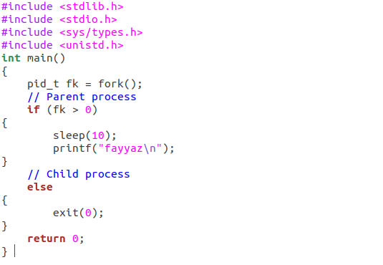
output:

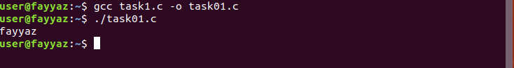
TASK 02:

orphan code:

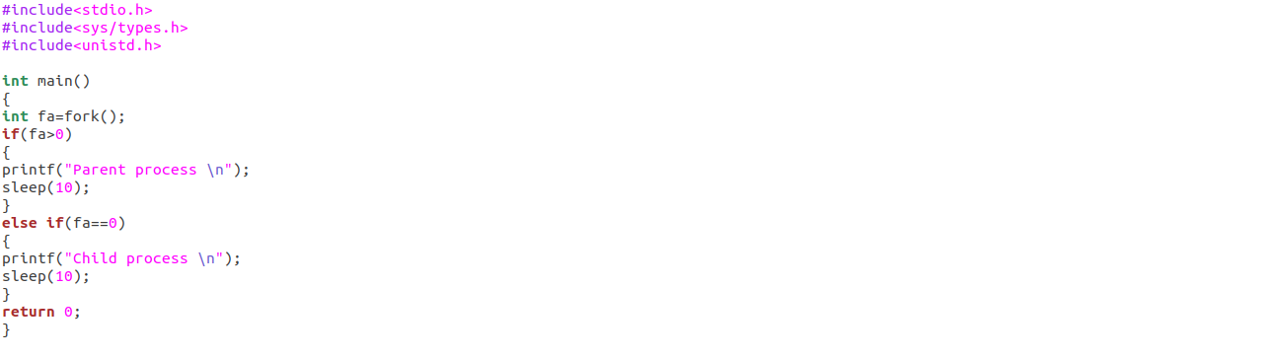
output:

